Sprint 5 Report – Apr 16th – 23rd

# Stories Completed

* CSOFT-97 - As a CrowSoft Designer I would like to create a Graphic Mockup of the app SO THAT use steps have visual representation.
* CSOFT-102 – As a DevOps team member , Create a sonarqube server , to review code quality and code coverage
* CSOFT-103 – As CrowSoft engineer I would like start setting up the pipeline on Jenkins so that automated builds will run
* CSOFT-104 – As a CrowSoft Administrator, I would like to add the configuration table for default building features, so that building features can be selected when a customer enters building details
* CSOFT-105 – As a CrowSoft Engineer, I would like to update the Database Design documentation, so that we can reflect the changes of the AspNetUsers added
* CSOFT-106 – As CrowSoft Engineer, I would like to add role-based security on the UI, so that we can limit access to roles
* CSOFT-107 – AS A CrowSoft engineer I WANT to install and configure a backup plugin in Jenkins SO THAT we can backup files in Jenkins
* CSOFT-108 – AS A CrowSoft engineer I WANT to install and configure an Audit Trail plugin in Jenkins SO THAT we have a record of who works in Jenkins
* CSOFT-109 – As A CrowSoft Team Member, I WOULD like to add access requirements for our reviewer, SO THAT the reviewer has access to our tools and servers
* CSOFT-110 – As a CrowSoft Engineer, I would like to create a Selenium Test Project using Visual Studio Code, so that we can run tests for the UI on our Web Application
* CSOFT-111 – AS A DevOps team member I WANT documentation SO THAT I can understand what is ongoing within the project.
* CSOFT-112 – AS A DevOps team member I WANT document videos (how to) SO THAT I can understand how to complete tasks/actions within the project.

# Stories In Progress

* CSOFT-54 - As a CrowSoft engineer I WANT to deploy and test SELENIUM on our DEV server
* CSOFT-62 - As CrowSoft Repository owner I would like to add webhook to github to allow Jenkins to trigger build
* CSOFT-113 - AS A team member I WANT to create a PowerPoint SO THAT we can present to the client

# Stories Not Started

* CSOFT-101 - AS A team member I WANT to create a Disaster Recovery plan for the Project

# Moving Forward

Three stories carried forward; one story not started.

# Burndown Chart

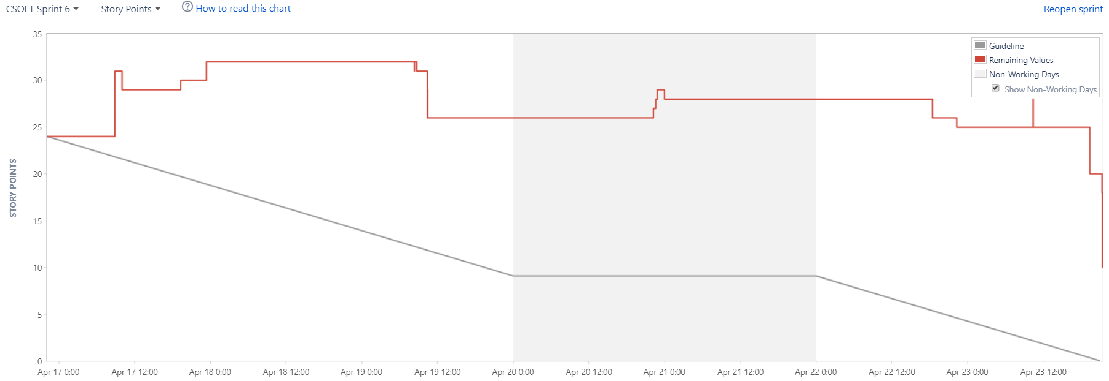

# Status Report

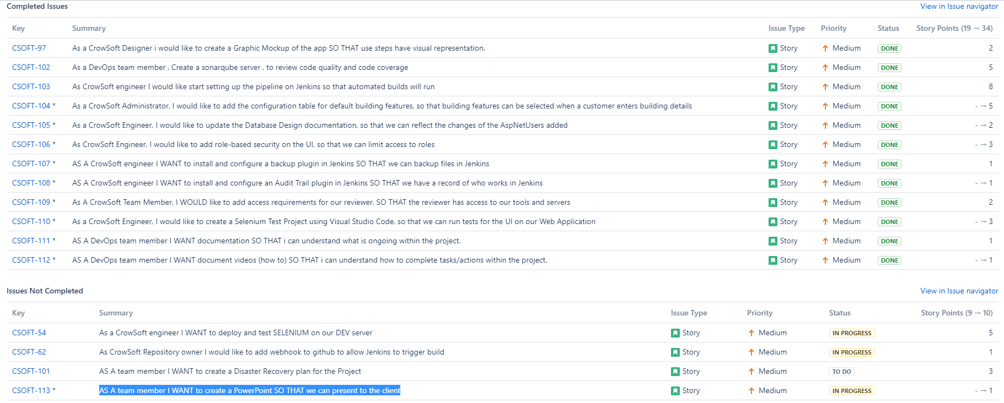

# Velocity Chart

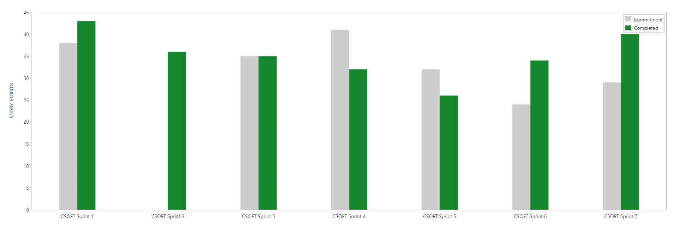

# Cumulative Flow Diagram

